# 

**l** 07432310923 **l** 07808550965 **l**

**l www.samericservicesltd.co.uk l**

**l Email: info@samericservicesltd.com l**

Dear HMO Landlord of Croydon,

I am writing to you to introduce myself as Eric, the Company Manager of SAMERIC SERVICES LTD. We are a well-established HMO Lettings Agency in London, who specialise in the management of professional shared houses.

We work closely with a number of companies within the area in order to house their employees and with the imminent arrival of the Westfield shopping centre in Croydon we have a growing number of working professionals looking for accommodation. Our promise to our clients is to provide their key members of staff with high-quality accommodation, within London, whenever they need it. Our promise to the landlord is to guarantee their rental income for the duration of our contract

We understand the needs of the Landlord, as we own many of our own licensed HMO homes and we are based in Croydon. We also work very closely with Landlords like yourself, who own property in and around Croydon. We will rent a property from our Landlords on a long-term basis, provide a light refurbishment if needed (provided and funded by us, as part of our service), cover all household bills, *and* guarantee rent to you each and every month, for anywhere between 3 to 5 years or more.

Once refurbished, SAMERIC houses have a high end boutique feel, with our key differences being the high end finish of our property’s, together with only housing full time working professionals.

Below are the promises we make to every Landlord we work with:

* We pay you a HMO guaranteed rental figure every month on a long term basis (3 to 5 years)
* We will pay you market rent – so there is no need for negotiation!
* We provide a light refurbishment to bring your property up to the high standards that we promise to our professional tenants (at no cost to you)
* We employ the services of a regular cleaner and gardener to maintain our high standards
* We manageall repairs & maintenance on your behalf
* The property is fully managed by our experienced Sameric services team at no cost to you
* There are NO tenant finding fees, NO inventory and NO management costs
* We would also consider purchasing the property in the future if of interest to you!

Please feel free to browse our website at [www.samericservicesltd.co.uk.](http://www.samericservicesltd.co.uk.) If your questions are not answered on our website, please call us to discuss over the telephone, or to arrange a no obligation meeting with myself.

Warmest regards,

Eric Mordi

Company Manager

SAMERIC SERVICES LTD

# 

**l** 07432310923 **l** 07808550965 **l**

**l www.samericservicesltd.co.uk l**

**l Email: info@samericservicesltd.com l**

## LANDLORD TESTIMONIALS

 SAMERIC SERVICES have been managing my properties for nearly a year now. Built on experience gained from managing their own portfolio, Sameric Services have built a very strong and

attractive offering to HMO (House of Multiple Occupancy) owners. They are incredibly proactive in terms of ensuring my properties are maintained to the highest standards, very reliable at paying the rent, and are very easy to talk to if ever I have a question. I have tried other agents before but they do not even compare – SAMERIC SERVICES make the process of renting an HMO so very simple, and I have been so impressed that I have given them all of my HMO’s to manage. If you are thinking of working with SAMERIC SERVICES, don’t even hesitate, say “Yes!”

## Alex, Landlord, Croydon

 SAMERIC SERVICES have been excellent property managers for us. Their monthly payment has always been submitted accurately and on time. They have shown significant respect to the property

and their tenants on the property. They have also refurbished the premises to a good standard at their own expense. I would highly recommend SAMERIC SERVICES for any landlord looking for a great service without having to pay any fees!

## Michelle, Landlord, Purley

 As a landlord, I have worked with SAMERIC SERVICES for several months and have been impressed by their attention to detail and standard of tenants. They seem to be particularly interested in getting things right.

## Keith Elsworth, Landlord, Croydon

 SAMERIC SERVICES have recently taken over the management of my property in Leonard road, Croydon. There has been a transitional period of about 6 months in which SAMERIC SERVICES have sensitivity

and sympathetically dealt with existing tenants and completely upgraded the property. At all times SAMERIC SERVICES have updated me, sought permission (my opinion of proposed changes) and maintained a professional approach to all situations.

We are delighted with the outcome and as such had no hesitation in extending our contract with SAMERIC SERVICES.

## Tony, Landlord, Croydon

**Before refurbishment…**

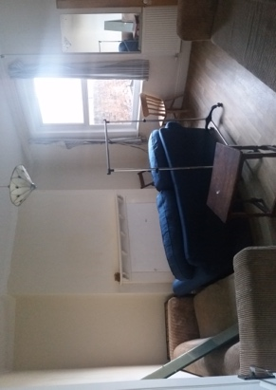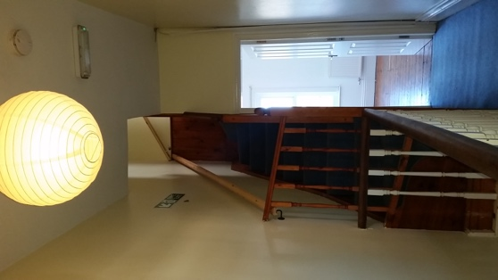

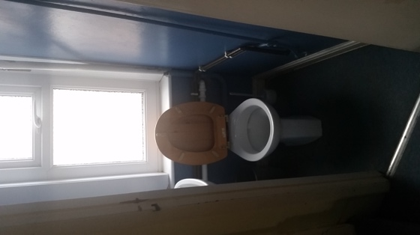

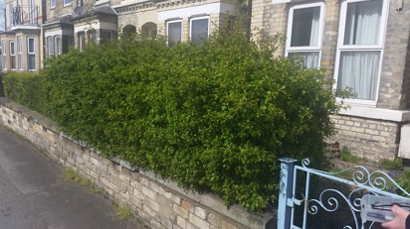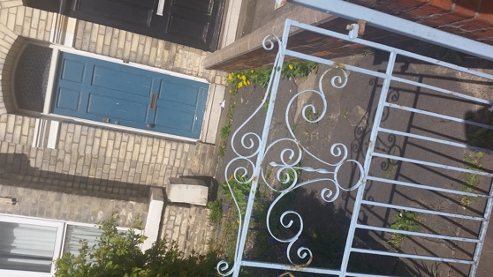

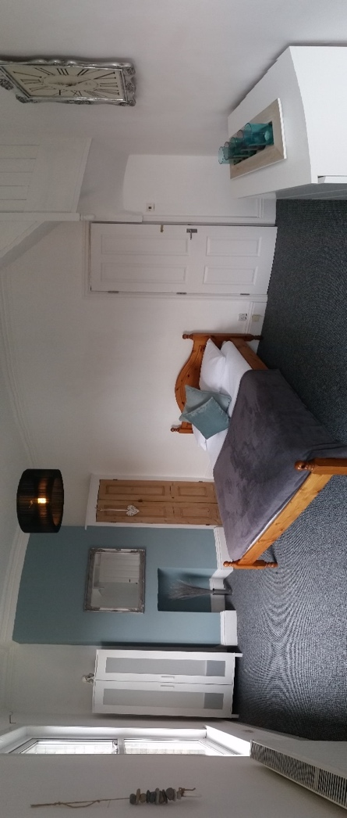

**…After refurbishment!**

